**MODIFICATIONS iIN iAIRCRAFT iPAINT iHANGAR**

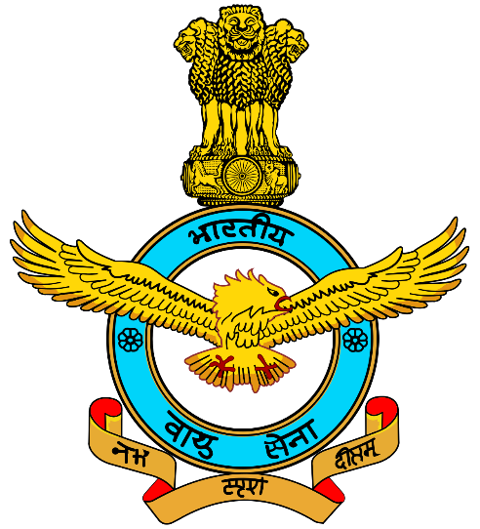

**A iPROJECT iREPORT**

In ipartial ifulfilment iof iindustrial itraining ifor ithe iaward iof ithe

Degree

Of

**BACHELOR iOF iTECHNOLOGY**

In

**AEROSPACE iENGINEERING**

From

**AMITY iUNIVERSITY, iNOIDA**

**UTTAR iPRADESH**

Completed iat

**5 iBASE iREPAIR iDEPOT, iAIR iFORCE iSTATION**

**SULUR, iCOIMBATORE, iTAMIL iNADU**

**CERTIFICATE**

This iis ito icertify ithat ithe isummer iinternship iproject i

report ititled i**‘Modifications iin iAircraft iPainting iHangar’** isubmitted ito i**5 iBRD, iAIR iFORCE iSTATION iSULUR** iis ia ibonafide irecord iof iwork idone iby ithe istudents imentioned iof i**2ND iYEAR, iB.Tech iAE, iAMITY iUNIVERSITY iNOIDA** iunder imy isupervision iand iguidance ifrom i**20th iMay i2019 ito i14th iJune i2019 i(Four iWeeks).** i

**TECH iHEADQUARTERS**

**5 iBASE iREPAIR iDEPOT**

**AIR iFORCE iSTATION iSULUR**

**COIMBATORE, iTAMIL iNADU** i

**DATE: i i**

**PLACE: iSULUR, iCOIMBATORE**

**i**

**DECLARATION**

This iis ito ideclare ithat ithis iproject ihas ibeen iwritten iby ius. iNo ipart iof ithe ireport ihas ibeen iplagiarized ifrom iother isources. i iAll iinformation iincluded ifrom iother iresources ihas ibeen iduly iacknowledged. iWe iaver ithat iif iany ipart iof ithe ireport iis ifound ito ibe iplagiarized, iwe iwill itake ifull iresponsibility ifor iit. i

i i i i i

|  |  |  |  |
| --- | --- | --- | --- |
| **S.No.** | **Name iof iStudent** | **Department** | **Signature** |
| 1. | Shanmukha iReddy iCH | B.Tech i(AE) |  |
| 2. | Alno iJohn iJoseph | B.Tech i(AE) |  |
| 3. | Prason. iS | B.Tech i(AE) |  |
| 4. | Yash iRaj | B.Tech.+M.Tech.(AE)-Intg. |  |
| 5. | Srajan iShrivastava | B.Tech.+M.Tech.(AE)-Intg. |  |

**ACKNOWLEDGEMENT**

To iacknowledge ihere, iall ithose iwho ihave ibeen ia ihelping ihand iin icompleting ithis iproject, ishall ibe ian iendeavor iin iitself. iWe itake ithis iopportunity ito ithank iall ithose iwho ihave ibeen iinstrumental iin icompletion iof ithe iproject i**‘Modification iin iAircraft iPaint iHangar’**.

First iof iall, iwe iwould ilike ito iexpress iour igratitude itowards ithe ialmighty iand iour iparents ifor isuccessful icompletion iof ithis iproject.

We iwould ilike ito ithank i**Air iCmdr iAtul iGarg** iand i**Sqn iLdr iMonica iLakshkar** iand i**WG iCmdr iIshwaran** ifrom i**Tech iHQ i5 iBRD** iwho ihave igiven ius inecessary iguidelines iand isupport ithroughout ithe iproject iin ispite iof ibeing ibusy iwith itheir iduties. i

It iis ialso iour ipleasure ito iconvey ibest iregards ito i**Anthony iGeorge i**sir ifor ithe ipaint ihangar isection, i**CPL iRavi iSingh** ifrom ithe idocument isection iof iDornier iaircraft iand i**WO iB. iSingh** ifrom iDornier isection ifor itheir ivaluable ihelp iand iadvice iduring ithe iproject. i

We iperceive ithis iopportunity ias ia imilestone iin iour icareer idevelopment iand iwe iwill istrive ito iuse ithe igained iskills iand iknowledge iin ithe ibest ipossible iway. iWe ihope ito icontinue icooperation ifrom iall iof iyou iin ithe ifuture. i

Sincerely, i

Shanmukha iReddy iCH, iAlno iJohn iJoseph, iPrason. iS, iYash iRaj, iSrajan iShrivastava.

**Contents**

* Introduction
* Materials iand iChemicals iused iin iPainting
  + Finishing iMaterials
  + Primers
  + Identification iof iPaints
* Current iProcedure iof iPainting
* Modifications iRequired iin iAircraft iPaint iHangar
* Automated iPainting iSystem
* Automated iPaint iSystem iComponents
* Conclusion
* References

**Introduction**

Piaint, ioir imiore ispeicifically iits ioiverall iciolor iand iappilication, iis iuisually itihe ifiirst iimipression ithiat iis itranismitted ito isoimeone iwihen ithiey iloiok iat ian iairicraft ifor ithe ifirist itiime. iPiaint imaikes ia istateiment iaibout ithe iaircriaft iand ithe ipierson iwho ioiwns ior iopeirates iit. iThe ipiiaint isciheme imay irefliect ithe iowiner’s iideias iand icoilor iprefereinces ifor ian iamiateur-built iairicraft iproiject, ior iit imiay ibe iciolors iand iideintification ifior ithe irecognitiion iof ia icorporatei ior iair icarriier iaiircraft.

Piaint iis imore ithan iaesthetics; iit iaffects ithe iweight iof ithe iaircraft iand iprotects ithe iintegrity iof ithe iairframe. iThe itopcoat ifinish iis iapplied ito iprotect ithe iexposed isurfaces ifrom icorrosion iand ideterioration. iAlso, ia iproperly ipiainted iaircraft iis ieasier ito iclean iand imaintain ibecause ithe iexposed isurfaces iare imore iresistant ito icorrosion iand idirt, iand ioil idoes inot iadhere ias ireadily ito ithe isurface.

A iwide ivariety iof imaterials iand ifinishes iare iused ito iprotect iand iprovide ithe idesired iappearance iof ithe iaircraft. iThe iterm i“Piaint” iis iused iin ia igeneral isense iand iincludes iprimers, ienamels, itacquers, iand ithe ivarious imultipart ifinishing iformulas. iPiaint ihas ithree icomponents: iresin ias icoating imaterial, ipigment ifor icolor, iand isolvents ito ireduce ithe imix ito ia iworkable iviscosity.

Internal istructure iand iunexposed icomponents iare ifinished ito iprotect ithem ifrom icorrosion iand ideterioration. iAll iexposed isurfaces iand icomponents iare ifinished ito iprovide iprotection iand ito ipresent ia ipleasing iappearance. iDecorative ifinishing iincludes itrim istriping, ithe iaddition iof icompany ilogos iand iemblems, iand ithe iapplication iof idecals, iidentification inumbers, iand iletters.

**Materials iand iChemicals iused iin iPiainting**

**Finishing iMaterials**

**i**

A iwide ivariety iof imaterials iare iused iin iaircraft ifinishing. iSome iof ithe imore icommon imaterials iand itheir iuses iare idescribed iin ithe ifollowing iparagraphs.

**Acetone: i**Acetone iis ia ifast-evaporating icolorless isolvent. iIt iis iused ias ian iingredient iin ipiaint, inail ipolish, iand ivarnish iremovers. iIt iis ia istrong isolvent ifor imost iplastics iand iis iideal ifor ithinning ifiberglass iresin, ipolyester iresins, ivinyl, iand iadhesives. iIt iis ialso iused ias ia isuperglue iremover. iAcetone iis ia iheavy-duty idegreaser isuitable ifor imetal ipreparation iand iremoving igrease ifrom ifabric icovering iprior ito idoping. iIt ishould inot ibe iused ias ia ithinner iin idope ibecause iof iits irapid ievaporation, iwhich icauses ithe idoped iarea ito icool iand icollect imoisture. iThis iabsorbed imoisture iprevents iuniform idrying iand iresults iin iblushing iof ithe idope iand ia iflat ino-gloss ifinish.

**Alcohol: i**Butanol, ior ibutyl ialcohol, iis ia islow-drying isolvent ithat ican ibe imixed iwith iaircraft idope ito iretard idrying iof ithe idope ifilm ion ihumid idays, ithus ipreventing iblushing. iA imixture iof idope isolvent icontaining i5 ito i10 ipercent iof ibutyl ialcohol iis iusually ienough ifor ithis ipurpose. iButanol iand iethanol ialcohol iare imixed itogether iin iratios iranging ifrom i1:1 ito i1:3 ito iuse ito idilute iwash icoat iprimer ifor ispray iapplications ibecause ithe ibutyl ialcohol iretards ithe ievaporation irate.

Ethanol ior idenatured ialcohol iis iused ito ithin ishellac ifor ispraying iand ias ia iconstituent iof ipiaint iand ivarnish iremover. iIt ican ialso ibe iused ias ia icleaner iand idegreaser iprior ito ipiainting.

Isopropyl, ior irubbing ialcohol, ican ibe iused ias ia idisinfectant. iIt iis iused iin ithe iformulation iof ioxygen isystem icleaning isolutions. iIt ican ibe iused ito iremove igrease ipencil iand ipermanent imarker ifrom ismooth isurfaces, ior ito iwipe ihand ior ifingerprint ioil ifrom ia isurface ibefore ipiainting. i

**Benzene: i**Benzene iis ia ihighly iflammable, icolorless iliquid iwith ia isweet iodor. iIt iis ia iproduct iused iin isome ipiaint iand ivarnish iremovers. iIt iis ian iindustrial isolvent ithat iis iregulated iby ithe iEnvironmental iProtection iAgency i(EPA) ibecause iit iis ian iextremely itoxic ichemical icompound iwhen iinhaled ior iabsorbed ithrough ithe iskin. iIt ihas ibeen iidentified ias ia iClass iA icarcinogen iknown ito icause ivarious iforms iof icancer. iIt ishould i

be iavoided ifor iuse ias ia icommon icleaning isolvent ifor ipiaint iequipment iand ispray iguns.

**Methyl iEthyl iKetone i(MEK): i**Methyl iethyl iketone i(MEK), ialso ireferred ito ias i2-Butanone, iis ia ihighly iflammable, iliquid isolvent iused iin ipiaint iand ivarnish iremovers, ipiaint iand iprimer ithinners, iin isurface icoatings, iadhesives, iprinting iinks, ias ia icatalyst ifor ipolyester iresin ihardening, iand ias ian iextraction imedium ifor ifats, ioils, iwaxes, iand iresins. iBecause iof iits ieffectiveness ias ia iquickly ievaporating isolvent, iMEK iis iused iin iformulating ihigh isolids icoatings ithat ihelp ito ireduce iemissions ifrom icoating ioperations. iPersons iusing iMEK ishould iuse iprotective igloves iand ihave iadequate iventilation ito iavoid ithe ipossible iirritation ieffects iof iskin icontact iand ibreathing iof ithe ivapors.

**Methylene iChloride: i**Methylene iChloride iis ia icolorless, ivolatile iliquid icompletely i

miscible iwith ia ivariety iof iother isolvents. iIt iis iwidely iused iin ipiaint istrippers iand ias ia icleaning iagent/degreaser ifor imetal iparts. iIt ihas ino iflash ipoint iunder inormal iuse iconditions iand ican ibe iused ito ireduce ithe iflammability iof iother isubstances. i

**Toluene: i**Referred ito ias itoluol ior imethylbenzene, itoluene iis ia iclear, iwater-insoluble iliquid iwith ia idistinct iodor ilike ithat iof ibenzene. iIt iis ia icommon isolvent iused iin ipiaints, ipiaint ithinners, ilacquers, iand iadhesives. iIt ihas ibeen iused ias ia ipiaint iremover iin isoftening ifluorescent-finish, iclear-topcoat isealing imaterials. iIt iis ialso ian iacceptable ithinner ifor izinc ichromate iprimer. iIt ihas ibeen iused ias ian iantiknocking iadditive iin igasoline. iProlonged iexposure ito itoluene ivapors ishould ibe iavoided ibecause iit imay ibe ilinked ito ibrain idamage.

**Thinners: i**Thinners iinclude ia iplethora iof isolvents iused ito ireduce ithe iviscosity iof iany ione iof ithe inumerous itypes iof iprimers, isubcoats, iand itopcoats.

**Primers**

The iimportance iof iprimers iin ifinishing iand iprotection iis igenerally imisunderstood iand iunderestimated ibecause iit iis iinvisible iafter ithe itopcoat ifinish iis iapplied. iA iprimer iis ithe ifoundation iof ithe ifinish. iIts irole iis ito ibond ito ithe isurface, iinhibit icorrosion iof imetal, iand iprovide ian ianchor ipoint ifor ithe ifinish icoats. iIt iis iimportant ithat ithe iprimer ipigments ibe ieither ianodic ito ithe imetal isurface ior ipassivate ithe isurface ishould imoisture ibe ipresent. iThe ibinder imust ibe icompatible iwith ithe ifinish icoats. iPrimers ion inonmetallic isurfaces ido inot irequire isacrificial ior ipassivating ipigments. iSome iof ithe ivarious iprimer itypes iare idiscussed ibelow.

**Wash iPrimers: i**Wash iprimers iare iwater-thin icoatings iof iphosphoric iacid iin isolutions iof ivinyl ibutyral iresin, ialcohol, iand iother iingredients. iThey iare ivery ilow iin isolids iwith ialmost ino ifilling iqualities. iTheir ifunctions iare ito ipassivate ithe isurface, itemporarily iprovide icorrosion iresistance, iand iprovide ian iadhesive ibase ifor ithe inext icoating, isuch ias ia iurethane ior iepoxy iprimer. iWash iprimers ido inot irequire isanding iand ihave ihigh icorrosion iprotection iqualities. iSome ihave ia ivery ismall irecoat itime iframe ithat imust ibe iconsidered iwhen ipiainting ilarger iaircraft. iThe imanufacturers’ iinstructions imust ibe ifollowed ifor isatisfactory iresults. i i

**Red iIron iOxide: i**Red ioxide iprimer iis ian ialkyd iresin-based icoating ithat iwas ideveloped ifor iuse iover iiron iand isteel ilocated iin imild ienvironmental iconditions. iIt ican ibe iapplied iover irust ithat iis ifree iof iloose iparticles, ioil, iand igrease. iIt ihas ilimited iuse iin ithe iaviation iindustry. i

**Gray iEnamel iUndercoat: i**This iis ia isingle icomponent, inon isanding iprimer icompatible iwith ia iwide ivariety iof itopcoats. iIt ifills iminor iimperfections, idries ifast iwithout ishrinkage, iand ihas ihigh icorrosion iresistance. iIt iis ia igood iprimer ifor icomposite isubstrates.

**Urethane: i**This iis ia iterm ithat iis imisused ior iinterchanged iby ipiainters iand imanufacturers ialike. iIt iis itypically ia itwo-part iproduct ithat iuses ia ichemical iactivator ito icure iby ilinking imolecules itogether ito iform ia iwhole inew icompound. iPolyurethane iis icommonly iused iwhen ireferring ito iurethane, ibut inot iwhen ithe iproduct ibeing ireferred ito iis iacrylic iurethane. iUrethane iprimer, ilike ithe iurethane ipiaint, iis ialso ia itwo-part iproduct ithat iuses ia ichemical iactivator ito icure. iIt iis ieasy ito isand iand ifills iwell. iThe iproper ifilm ithickness imust ibe iobserved, ibecause iit ican ishrink iwhen iapplied itoo iheavily. iIt iis itypically iapplied iover ia iwash iprimer ifor ibest iresults. iSpecial iprecautions imust ibe itaken iby ipersons ispraying ibecause ithe iactivators icontain iisocyanates.

**Epoxy: i**Epoxy iis ia isynthetic, ithermosetting iresin ithat iproduces itough, ihard, ichemical-resistant icoatings iand iadhesives. iIt iuses ia icatalyst ito ichemically iactivate ithe iproduct, ibut iit iis inot iclassified ias ihazardous ibecause iit icontains ino iisocyanates. iEpoxy ican ibe iused ias ia inon isanding iprimer/sealer iover ibare imetal iand iit iis isofter ithan iurethane, iso iit ihas igood ichip iresistance. iIt iis irecommended ifor iuse ion isteel itube iframe iaircraft iprior ito iinstalling ifabric icovering. i

**Zinc iChromate: i**Zinc ichromate iis ia icorrosion-resistant ipigment ithat ican ibe iadded ito iprimers imade iof idifferent iresin itypes, isuch ias iepoxy, ipolyurethane, iand ialkyd. iOlder itype izinc ichromate iis idistinguishable iby iits ibright iyellow icolor iwhen icompared ito ithe ilight igreen icolor iof isome iof ithe icurrent ibrand iprimers. iMoisture iin ithe iair icauses ithe izinc ichromate ito ireact iwith ithe imetal isurface, iand iit iforms ia ipassive ilayer ithat iprevents icorrosion. iZinc ichromate iprimer iwas, iat ione itime, ithe istandard iprimer ifor iaircraft ipiainting. iEnvironmental iconcerns iand inew iformula iprimers ihave iall ibut ireplaced iit.

**Identification iof iPiaints**

**Dope: i**When ifabric-covered iaircraft iruled ithe isky, idope iwas ithe istandard ifinish iused ito iprotect iand icolor ithe ifabric. iThe idope iimparted iadditional iqualities iof iincreased itensile istrength, iairtightness, iweather-proofing, iultraviolet i(UV) iprotection, iand itautness ito ithe ifabric icover. iAircraft idope iis iessentially ia icolloidal isolution iof icellulose iacetate ior initrate icombined iwith iplasticizers ito iproduce ia ismooth, iflexible, ihomogeneous ifilm. i

Dope iis istill iused ion ifabric icovered iaircraft ias ipart iof ia icovering iprocess. iHowever, ithe itype iof ifabric ibeing iused ito icover ithe iaircraft ihas ichanged. iGrade iA icotton ior ilinen iwas ithe istandard icovering iused ifor iyears, iand iit istill imay ibe iused iif iit imeets ithe irequirements iof ithe iFederal iAviation iAdministration i(FAA), iTechnical iStandard iOrder i(TSO) iC-15d/AMS i3806c. i

Polyester ifabric icoverings inow idominate iin ithe iaviation iindustry. iThese inew ifabrics ihave ibeen ispecifically ideveloped ifor iaircraft iand iare ifar isuperior ito icotton iand ilinen. iThe iprotective icoating iand itopcoat ifinishes iused iwith ithe iCeconite® ipolyester ifabric icovering imaterials iare ipart iof ia iSupplemental iType iCertificate i(STC) iand imust ibe iused ias ispecified iwhen icovering iany iaircraft iwith ia iStandard iAirworthiness iCertificate. iThe iCeconite® icovering iprocedures iuse ispecific ibrand iname, inontautening initrate iand ibutyrate idope ias ipart iof ithe iSTC.

The iPoly-Fiber® isystem ialso iuses ia ispecial ipolyester ifabric icovering ias ipart iof iits iSTC, ibut iit idoes inot iuse idope. iAll ithe iliquid iproducts iin ithe iPoly-Fiber® isystem iare imade ifrom ivinyl, inot ifrom icellulose idope. iThe ivinyl icoatings ihave iseveral ireal iadvantages iover idope: ithey iremain iflexible, ithey ido inot ishrink, ithey ido inot isupport icombustion, iand ithey iare ieasily iremoved ifrom ithe ifabric iwith iMEK, iwhich isimplifies imost irepairs. i

**Synthetic iEnamel: i**Synthetic ienamel iis ian ioil-based isingle-stage iPiaint i(no iclear icoat) ithat iprovides idurability iand iprotection. iIt ican ibe imixed iwith ia ihardener ito iincrease ithe idurability iand ishine iwhile idecreasing ithe idrying itime. iIt iis ione iof ithe imore ieconomical itypes iof ifinish.

**Lacquers: i**The iorigin iof ilacquer idates iback ithousands iof iyears ito ia iresin iobtained ifrom itrees iindigenous ito iChina. iIn ithe iearly i1920s, initrocellulose ilacquer iwas ideveloped ifrom ia iprocess iusing icotton iand iwood ipulp. i

Nitrocellulose ilacquers iproduce ia ihard, isemiflexible ifinish ithat ican ibe ipolished ito ia ihigh isheen. iThe iclear ivariety iyellows ias iit iages, iand iit ican ishrink iover itime ito ia ipoint ithat ithe isurface icrazes. iIt iis ieasy ito ispot irepair ibecause ieach inew icoat iof ilacquer isoftens iand iblends iinto ithe iprevious icoat. iThis iwas ione iof ithe ifirst icoatings iused iby ithe iautomotive iindustry iin imass iproduction, ibecause iit ireduced ifinishing itimes ifrom i

almost itwo iweeks ito itwo idays. i

Acrylic ilacquers iwere ideveloped ito ieliminate ithe iyellowing iproblems iand icrazing iof ithe initrocellulose ilacquers. iGeneral iMotors istarted iusing iacrylic ilacquer iin ithe imid-1950s, iand ithey iused iit iinto ithe i1960s ion isome iof itheir ipremium imodel icars. iAcrylics ihave ithe isame iworking iproperties ibut idry ito ia iless ibrittle iand imore iflexible ifilm ithan initrocellulose ilacquer. i

Lacquer iis ione iof ithe ieasiest ipiaints ito ispray, ibecause iit idries iquickly iand ican ibe iapplied iin ithin icoats. iHowever, ilacquer iis inot ivery idurable; ibird idroppings, iacid irain, iand igasoline ispills ieat idown iinto ithe ipiaint. iIt istill ihas ilimited iuse ion icollector iand ishow iautomobiles ibecause ithey iare iusually ikept iin ia igarage, iprotected ifrom ithe ienvironment. i

The icurrent iuse iof ilacquer ifor ian iexterior icoating ion ian iaircraft iis ialmost inonexistent ibecause iof idurability iand ienvironmental iconcerns. iUpwards iof i85 ipercent iof ithe ivolatile iorganic icompounds i(VOCs) iin ithe ispray igun iends iup iin ithe iatmosphere, iand isome istates ihave ibanned iits iuse. i

There iare isome inewly ideveloped ilacquers ithat iuse ia icatalyst, ibut ithey iare iused imostly iin ithe iwoodworking iand ifurniture iindustry. iThey ihave ithe iease iof iapplication iof initrocellulose ilacquer iwith imuch ibetter iwater, ichemical, iand iabrasion iresistance. iAdditionally, icatalyzed ilacquers icure ichemically, inot isolely ithrough ithe ievaporation iof isolvents, iso ithere iis ia ireduction iof iVOCs ireleased iinto ithe iatmosphere. iIt iis iactivated iwhen ithe icatalyst iis iadded ito ithe ibase imixture. i

**Polyurethane: i**Polyurethane iis iat ithe itop iof ithe ilist iwhen icompared ito iother icoatings ifor iabrasion-, istain-, iand ichemical-resistant iproperties. iPolyurethane iwas ithe icoating ithat iintroduced ithe iwet ilook. iIt ihas ia ihigh idegree iof inatural iresistance ito ithe i

damaging ieffects iof iUV irays ifrom ithe isun. iPolyurethane iis iusually ithe ifirst ichoice ifor icoating iand ifinishing ithe icorporate iand icommercial iaircraft iin itoday’s iaviation ienvironment.

**Urethane iCoating: i**The iterm iurethane iapplies ito icertain itypes iof ibinders iused ifor ipiaints iand iclear icoatings. i(A ibinder iis ithe icomponent ithat iholds ithe ipigment itogether iin ia itough, icontinuous ifilm iand iprovides ifilm iintegrity iand iadhesion.) iTypically, iurethane iis ia itwo-part icoating ithat iconsists iof ia ibase iand icatalyst ithat, iwhen imixed, iproduces ia idurable, ihigh-gloss ifinish ithat iis iabrasion iand ichemical iresistant. i

**Acrylic iUrethanes: i**Acrylic isimply imeans iplastic. iIt idries ito ia iharder isurface ibut iis inot ias iresistant ito iharsh ichemicals ias ipolyurethane. iMost iacrylic iurethanes ineed iadditional iUV iinhibitors iadded iwhen isubject ito ithe iUV irays iof ithe isun.

**Current iprocedure iof iPainting**

Normal iPainting:

1. Complete iwater iwashing iof iaircraft iwith isoapy iwater iand iapplication iof iemery isheet ifor ismoothening ithe isurface.
2. Marking iof iareas iwhich iare inot ito ibe ipainted.
3. Application iof i“Desothane iGlossy idove igrey” ion ithe ientire isurface(two icoats).
4. All isurface imarking ias iper ithe istandard iformat iroundel, iflag iand iother iaircraft imarkings.
5. Under icarriage iand iwheel ihubs iare ipaints iin iduco ialuminium ipaints.
6. Painting iof ithe iinternal ipanels iand imarking.
7. Painting iof ithe iCFD idoor, ipassenger idoors iand ibaggage idoors.
8. Painting iof iluggage icompartment iin idark iadmiral igrey.
9. Demasking iactivity.
10. Removal iand ipasting iof itrack imarker ion iall iinternal ifloor ipanels iand iside ipanels.

Enhanced iPainting:

1. Removing iof igrey iand iall iother ipaints ipainted ion ithe iaircraft iupto ibare imetal iwith ipaint iremovals/chemicals.
2. Complete iwater iwashing iof iaircraft iwith isoapy iwater. iMasking iof iareas iwhich iare inot ito ibe ipainted.
3. Alochrome itreatment ion ithe ientire isurface iof ithe iaircraft.
4. Application iof ietch iprimer ion ithe ientire isurface iof ithe iaircraft.
5. Application iof izinc ichromatic iprimer isingle icoat ion ithe ientire isurface iof iaircraft.
6. Application iof i“Desothane iGlossy idove igrey” ion ithe ientire isurface(two icoats).
7. Painting iof ithe iinternal ipanels iand imarking.
8. Painting iof ithe iCFD idoor, ipassenger idoors iand ibaggage idoors.
9. Painting iof iluggage icompartment iin idark iadmiral igrey.
10. Demasking iactivity.
11. Removal iand ipasting iof itrack imarker ion iall iinternal ifloor ipanels iand iside ipanels.
12. Provision iof iprotective igoggles, ioveralls iand iother isafety iequipments ito ithe iworkers iby ithe icontractor iduring ipainting iactivities ito iprotect ithem ifrom ifumes.

**Modifications irequired iin iaircraft iPaint ihangar**

* **Closed iHangar: i**Paint ihangar ishould ibe iclosed iso ithat iwhile ipainting ithe iaircraft, iwe icould iprotect iit ifrom iexternal ienvironmental iimpurities ilike idust(due ito iwind, istorm, irain, ietc.), iwater idroplets iof irain, isnow, iand ieven ismall ifactors ilike ibacteria iand iother imicrobes iwhich ican ilower ithe iquality iof iPainting iand imess iup iwith ithe icomposition iof ithe ipaint iwhich iis ito ibe iused ifor ithe iaircraft iand ithus ican icause ivarious iproblems.
* **Proper itradesmen: i**If iproper itradesmen iare imade iavailable iinside i5, iBase iRepair iDepot iwe ican ieasily ipurchase ipaints ifrom ithe icomplex ionly. iThis iwill ireduce ithe itime iof idelivery iof ipaints ifor ithe iaircraft iand icertain itypes iof ipaints iwill ibe iavailable ieasily iand iat ia ilow icost iprice.
* **Grounding ior iEarthing: i**Earthing iis imainly irequired ito iground iall ithe istatic icharges iwhich iare iacquired i iby ithe iworkers. iThese icharges imay idisrupt ithe iworking iof iinternal ielectrical icomponents iof ithe iaircraft.
* **Proper ijob icard iof ieach iaircraft: i**Keeping ia iproper irecord iby iusing ithe ijob icards ican ihelp ius iin iproper imanagement iof ithe ipaintjob iof ithe iaircraft.
* **Curing itemperature: i**A isuggested itemperature iof ithe ipaint ihangar iwhich iis ibetween i18° ito i30° iCelsius imust ibe imaintained iif iwe iare ito iachieve iworld-class ipainting iof ithe iaircraft.
* **Low iweight iladders:** iLow iweight iladders imust ibe iused iby ithe iworkers ito idecrease ithe ipressure iacting ion ithe isurface iof iaircraft iand itherefore iit ican ibe iused ito ireduce ithe istructural idamage ithat ihappens ito ithe iaircraft iduring ithe iprocess.
* **Tools iand itesters:** iProper itools iand itesters imust ibe ithere ifor ithe iworkers iand itechnicians iwhich ican imake ipainting iof ithe iaircraft imore iefficient.
* **Mesh itype ifloor:** iA ispecial itype iof ifloor icalled ithe imesh itype ifloor imust ibe iinstalled iin iorder ito iabsorb ithe ifumes icoming iout ifrom ithe iairplane iexhausts. iA idrainage isystem iis iinstalled iin ithis itype iof ifloor iwhich iabsorbs ithese ifumes iand icarry iit ioutside ithe ipaint ihangar.
* **Proper iUniform:** iA ifull ibody isuit imust ibe igiven ito ithe iworkers iworking ion ithe iaircraft ito imaintain ihealth iof ithe iworkers iwhich ican icome iin icontact iwith ithe ifumes iof ithe iaircraft.
* **Smooth iwalls:** iWalls imust ibe imade ismooth iso ithat ithey icannot iabsorb ithe ifumes iand ithus iit iwill ibeautify ithe ipaint ihangar ifor ia ilonger iperiod.
* **Auto iCoat:** iAn iauto icoat ilike icellulose imust ibe iadded ito ithe ipaint iwhich iis ito ibe iapplied ion ithe iaircraft ito iincrease ithe iglittering ieffect iproduced iby ithe ipaint. iThis iwill ibeautify ithe iaircraft iand ithus iaircraft ipainting iwill ibecome iworld iclass.
* **Fire iExtinguishers, iOxygen icylinders, iFirst iAid:** iAn iaircraft ipaint ihangar imust ibe iproperly iequipped iwith ifew ibasic ithings ilike ifire iextinguishers, ioxygen icylinders iand ifirst iaid ifor ithe isafety ipurposes iso ithat iduring iany iaccidents ihelp ican ieasily ibe iprovided.
* **Curtains ion imain idoors:** iCurtains ion ithe imain idoors imust ibe iinstalled ito iminimize ithe iinteraction iwith ithe iexternal ienvironmental ifactors.
* **Sufficient iLightings:** iThere imust ibe ia iproper ilighting isystems iin ithe ipaint ihangar ifor ibetter ivisual iinspection iby ithe iworkers.
* **Proper icleaning:** iPaint ihangar imust ibe icleaned ifrom itime ito itime iso ithat idust iparticles idoes inot istick ito ithe ifloor iand ipainted isurface iof ithe iaircraft.
* **Proper iwater isupply:** iIn icase ipainting iis idone iunevenly ion ithe isurface, ithere imust ibe ia iproper iwater isupply iso ithat ithe ipaint ican iimmediately ibe iremoved.
* **Regulators: i**There imust ibe ioptimum iamount iof iregulators ior isockets ito imanage iproper ielectrical isupply ifor ithe ivarious iequipments.
* **Standard icolor ifor ipainting:** iPainting imust ibe idone iwith ithe istandard icolors ithat iare iprovided iby ithe igovernment iguidelines ito imaintain ithe iair iforce istandards.
* **Pipelines:** iProper ipipelines ifor isupply iof iwater, iair, ifire, ietc. imust ibe iinstalled iin ithe ipaint ihangar. iThese ipipelines ishould ibe icolor icoded iso ithat iif isome iproblem ioccurs iit iwill ibe ieasy ito ilocate ithem.
* **Dustbins:** iSufficient iamount iof idustbins imust ibe iprovided ito imaintain iproper idecorum iand icleanliness iinside ithe ipaint ihangar.

**Automated iPainting iSystem**

As iIndia iis ideveloping iin ithe iaviation isector, inumber iof iaircrafts iwhich iare iused iand imaintained iby ithe iIndian iAir iForce iis ialso iincreased. iSo iwith ithe iuse iof iour icurrent itechnology, ithe itime iwhich iis iconsumed iduring ipainting iof ithe iaircrafts iis ia ilot. iIn iorder ito icope iup iwith ithese iincreased inumbers iof ithe iaircraft, ia imajor istep iis irequired iin ithis ifield. iThis istep ican ibe itaken iby iintroducing ithe iautonomous ior irobotic isystem iin ithe iaircraft ipaint ihangar.

This iwill inot ionly idecrease ithe itime iwhich iis iconsumed iin ithis itedious itask ibut iwill ialso iadd iaccuracy iand iprecision iin ithe iprocess iof ipainting. iAlso ithis iwill ireduce ithe imanpower iwhich iwill ihelp iIAF ito idecrease itheir iexpenses iand ialso ia ilarge inumber iof iaircraft ican ibe ipainted iat ia itime.

**Advantages iof iRobotic iPainting:**

* Lower ioperating icost iby ireducing imaterial iwaste iup ito i30%.
* Reduce ilabor icosts iwhile idramatically iimproving iquality, ireducing iscrap iand irework idue ito ioperator ierror.
* Protect iemployees ifrom idangerous iconditions iand irepetitive itasks.
* Achieve ihigh itransfer iefficiency, ilowering ithe iamount iof ipaint isprayed, iVOCs, iand iwaste idisposal.

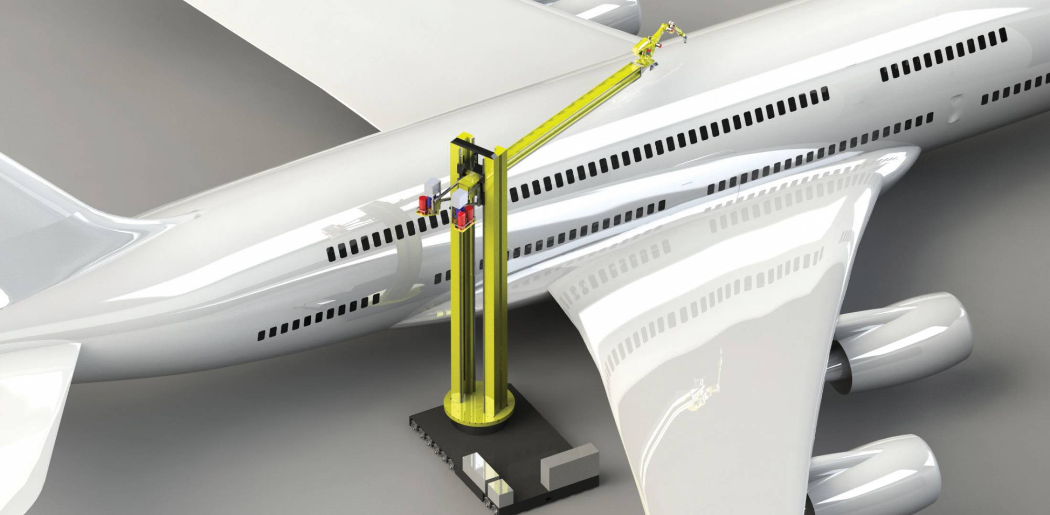

**Automated iPiaint iSystem iComponents:**

### 15285AirPro iAuto

AirPro iAutomatic iguns ihave ia iwide istandard iproduct ioffering iwith icompliant igun imodels, iin iaddition ito iHVLP iand iconventional. iIdeal ifor imetal, iwood iand ihigh iwear iapplications.

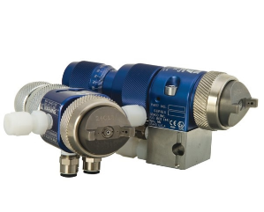**AirPro iEFX**

AirPro iEFX iair ispray iautomatic iguns iare iamong ithe ilightest iand imost icompact iguns iin itheir iclass. iWith ino iinternal iair ishutoff imechanism, ithe iAirPro iEFX idelivers iincreased ireliability iand iprecision ifluid iflow.

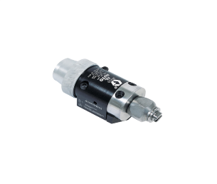

**AL iSeries iAuto**

Graco’s iAL iSeries iAutomatic ispray iguns ifor iairless ispraying iof ipaints iand icoatings. iIdeal ifor igeneral imetal iapplications.

### 15062G40 iAuto

Graco’s iG40 iAutomatic iAir-Assisted ispray iguns ifor iliquid icoatings iare i i i i i i i i i i i i i i i i i i i i i i i i i i i i i i i i i i irecommended ifor ihigh ifinish iquality iapplications iat ilow iand imedium ipressure.

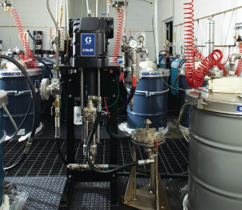

**Intelligent iPaint iKitchen iSystem**

Increase iefficiency iwith iremote imonitoring iand icontrol. iThe iIntelligent iPaint iKitchen iis ia icomplete, icost ieffective isolution ifor ithe ientire ipaint iroom.

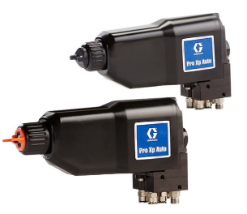

**Pro iXp iAuto**

Pro iXp iautomatic ielectrostatic ispray iguns ideliver iexpert iperformance ito iautomated iPaint ilines. iAchieve ihigh itransfer iefficiency iwhen ispraying ihigh iconductivity, istandard ior iwaterborne icoating.

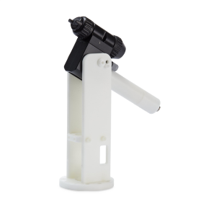

**Pro iXpc iAuto**

The iPro iXpc iAuto ielectrostatic ispray igun ioffers iexcellent ifinish iquality, ileading iclass itransfer iefficiency iand iis ijust ithe iright isize ifor irobots iand ifixtures iwith ipayload ilimits.

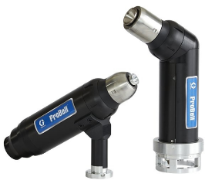

**ProBell**

Graco’s iProBell iRotary iApplicators inot ionly ideliver ia isuperior iquality, ihigh itransfer iefficiency iand iprecision ispraying, iit’s ialso ilightweight iand icompact ifor ilower ipayload irobots ior ireciprocators.

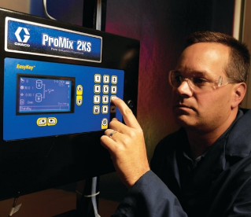

**ProMix i2KS**

Graco’s iProMix i2KS iPlural iComponent iMixing iSystem ioffers iprecise iand ireliable ielectronic iproportioning ifor ientry ilevel ito iupgraded iapplications. iCompatible iwith ia ibroad irange iof imaterials, iit iprovides ithe iflexibility iand iefficiency iyou ineed ion iyour iproduction iline.

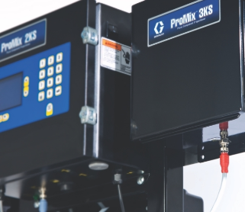

**ProMix i3KS**

Graco’s iProMix i3KS iPlural iComponent iMixing iSystem ioffers ithe isame iprecision iof ithe i2KS ifor ithree icomponent imaterials. iPurchase iwith ia iProMix i2KS isystem i ior iupgrade ian iexisting i2KS.

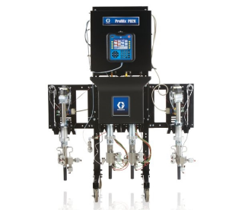**ProMix iPD**

The iProMix iPositive iDisplacement i(PD) iProportioner iPlatform iis iredefining ifluid icontrol, iplural icomponent imixing iand imanufacturing iprocesses. iStay ion iratio iwithin i1 ipercent imixing iaccuracy. iStay ion ibudget iwith iless irework iand isimple imaintenance.

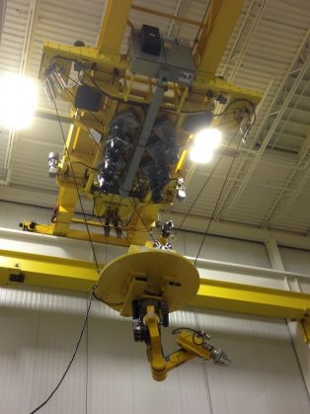

**Conclusion**

From ithe iabove istudy, iwe ican iconclude ithat ialthough imodifying ithe ipainting ihangar iinto ian iautomated ipainting ihangar iis ia ivery iexpensive isetup ibut iin ithe ilong irun, ithis isetup iwill iprove ito ibe ivery iefficient. iThe isystem iwill isave ithe imanpower iand iexpenses iof iIAF ican ireduce idrastically iand iproductivity iwill irise idramatically.

Therefore, iif iIndian igovernment ishows itheir iconcern iin ithis imajor istep iand ihelp iIAF iby iproviding ienough ifund iand isupport, ithen iIndia ican ibecome ione iof ithose icountries iwhich iwill iprovide iworld-class ipainting ifacilities ifor ithe iaircraft.

**References**

[www.google.com](http://www.google.com)

en.wikipedia.org

[www.flightradar24.com](http://www.flightradar24.com)

[www.armorpoxy.com](http://www.armorpoxy.com)

[www.materialstoday.com](http://www.materialstoday.com)

[www.graco.com](http://www.graco.com)

[www.conceptsystemsinc.com](http://www.conceptsystemsinc.com)

[www.ctisystems.com](http://www.ctisystems.com)

[www.globalfinishing.com](http://www.globalfinishing.com)

[www.wsp.com](http://www.wsp.com)

[www.par.com](http://www.par.com)

[www.sweethaven02.com](http://www.sweethaven02.com)